ISTANBUL
OFFICE REPORT
PRESS KIT
PRESS BULLETIN

CONTACT INFORMATION
2017
FIRST QUARTER
Propin Property Investment Consultancy
Buyukdere Caddesi, Gokfiliz İs Merkezi
No. 8/22 F. 9 Mecidiyekoy, Istanbul
T +90 212 217 85 55
F +90 212 217 85 53
info@propin.com.tr | www.propin.com.tr

PROPIN PROPERTY INVESTMENT CONSULTANCY PRESS BULLETIN
02.05.2017
2017 FIRST QUARTER ISTANBUL OFFICE MARKET GENERAL OVERVIEW
Propin, which offers Property Investment Consultancy service about renting and acquisition of offices, prepares a report on the Istanbul Office Market once every three month; the report of the first quarter of 2017 has just been released. It shows the changes that occurred in the office market during January, February, and March as well as shares Propin’s predictions for the upcoming periods.

Istanbul Office Market experienced a hectic period in the first quarter of 2017.
In the report, Propin stated that, in the first quarter of 2017, the Istanbul Office Market experienced a hectic period in spite of the fact that some companies decided to wait irrespective of the result to come out of the referendum. Propin indicated that, switching the currency stipulated in the contracts from a foreign one to Turkish Lira became a point of consideration for a large number of companies. Propin also stated that, fluctuation in the exchange rates and the absence of a sustainable environment of trust pressured landlords regarding the currencies used in the contracts. Propin conveyed that, this pressure was seen for those who obtained finance in foreign currency. Propin said that, it has also been observed that landlords who could not accept changing the medium of exchange in the contract to Turkish Lira chose between providing discounts in the list prices or pegging currency.

The growth in office stock slowed down.
In the report, Propin wrote that, a lack of a stock increase, the exception being in Torun Center and Quasar (both of which were launched in Zincirlikuyu-Esentepe-Gayrettepe in the CBD), was noteworthy. Propin revealed that, the stock share of the CBD, Out of CBD-Europe, Out of CBD-Asia and Developing Office District [Kagithane, Bomonti-Piyalepasa, Kartal-Maltepe, West Atasehir] was measured as 37%, 19%, 28% and %16 respectively.

Vacancy Rate increased in the CBD and in Out Of CBD-Asia but decreased in Out of CBD-Europe.
In the report, one can say that in the CBD, the vacancy rate for Class A office buildings in the CBD has increased throughout the last four quarters. It is said the vacancy rate for Class A office buildings in the CBD rose approximately 7% and was 27.7%. It is emphasized that, the increase in stock in Zincirlikuyu-Esentepe-Gayrettepe led to this uptick. On the other hand, it is relayed that, the vacancy rate for Class A office buildings in Out of CBD-Europe declined to 22.1%. Also, it is recalled that, the vacancy rate for Class A office buildings in Out of CBD-Asia was 16.5% in the second quarter of 2016. It is informed that, the vacancy rate for Class A office buildings in Out of CBD-Asia has shown an upward trend for the past four quarters, reaching 20.6% in the first quarter of 2017.

Average rental rates decreased in the CBD and in Out of CBD-Europe, yet steady in Out of CBD-Asia
In the report prepared by Propin, it is stated that, the average rent rate for Class A office buildings in the CBD demonstrated a tendency to decline during the period between the second quarter of 2016 and the first quarter of 2017. It is said that, In the initial quarter of this year, the average rent rate for Class A office buildings in the CBD dropped $US 1.2 /m² /month after four quarters. It is informed that, the average rent rate was measured at $US 26.9 /m² /month for Class A office buildings in the CBD in this quarter as well.
In the report, it is reminded that, in Out of CBD-Asia, the average rent rate for Class A office buildings was on the wane throughout the last three quarters of 2016 the average rental rate for Class A office buildings in Out of CBD-Asia fell throughout the last four quarters. It is revealed that, in the first quarter of 2017, the average rent rate for Class A office buildings in Out of CBD-Asia remained unchanged from the previous quarter and was measured at $US 18.4 /m² /month.

The summary of the report prepared by Propin “Istanbul Office Market in the first quarter of 2017” based on the latest data, is given below;

- While the vacancy rate for Class A office buildings in the Central Business District (CBD) was 27.7%, it was measured at 13.4% in Class B office buildings. The average rent for Class A office buildings in the CBD was $US 26.9 /m2 /month and $US 14.1 /m2 /month for Class B office buildings.

- The vacancy rate for Class A office buildings in Out of CBD-Europe was at a level of 22.1% and the average rent for Class A office buildings was $US 16.6 /m2 /month.

- For Class A office buildings in Out of CBD-Asia, the vacancy rate was determined to be 20.6%. The average rent for Class A office buildings was $US 18.5 /m2 /month.

- Located in the CBD, Levent commanded the top prime rent in the first quarter of 2017. The listed
prime rent was $US 45 /m2 /month in the district, just as it had been in the three previous quarters.

Levent was the district where the prime rent was set!

In the report that Propin has prepared, it is mentioned that, Levent was the district where the highest rent was asked in the CBD in the first quarter of 2017. It is revealed that, the figure was $US 45 /m2 /month, as it had been in the last three quarters. Also in the report, it is informed that, Kozyatagi and Altunizade commanded the top prime rent ($US 28 /m2 /month) in Out of CBD-Asia. It is said that, top prime rent demanded in Umraniye was lower when compared to the previous three quarters.

2017 FIRST QUARTER ISTANBUL OFFICE MARKET

GRAPHICS

02.05.2017

VACANCY RATES BY DISTRICT CATEGORY 2017 The First Quarter

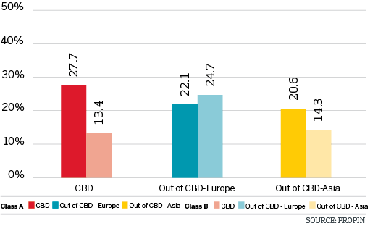

VACANCY RATES BY DISTRICT 2017 The First Quarter

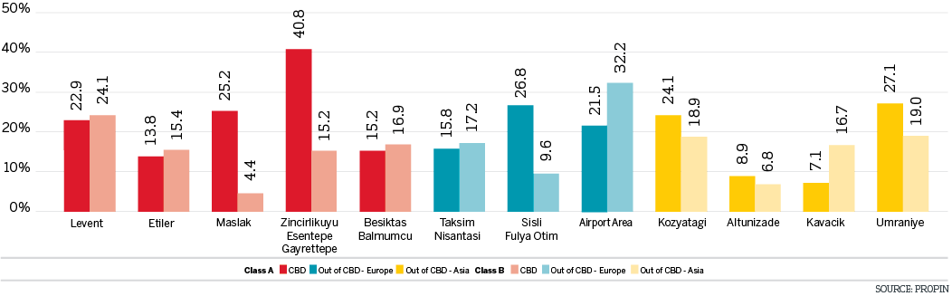

CHANGES IN VACANCY RATES OF CLASS A BUILDINGS The Last Four Quarters

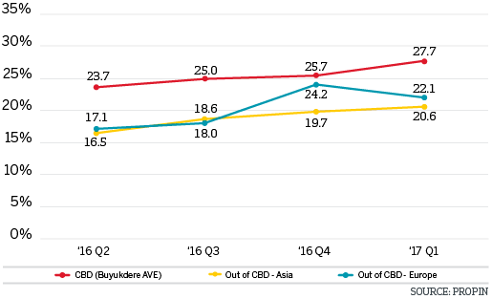

CHANGES IN VACANCY RATES OF CLASS B BUILDINGS The Last Four Quarters

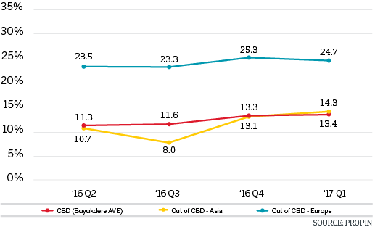

AVERAGE RENTAL RATES BY DISTRICT CATEGORY 2017 The First Quarter

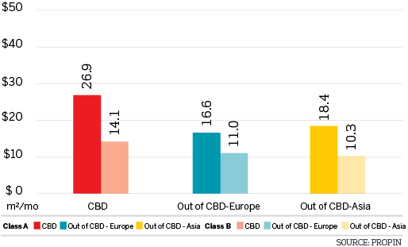

AVERAGE RENTAL RATES BY DISTRICT 2017 The First Quarter

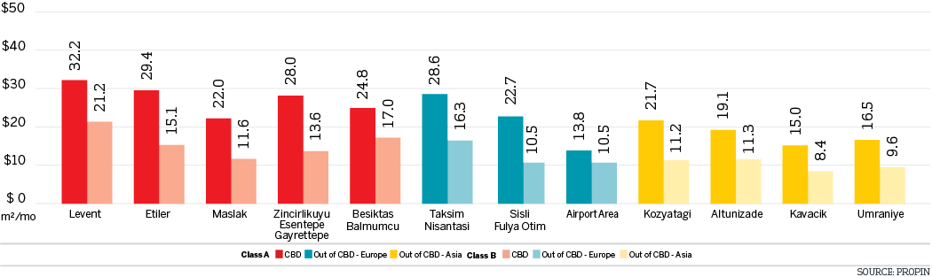

LISTING PRICES OF PRIME RENT BY DISTRICT IN ISTANBUL The Last Four Quarters

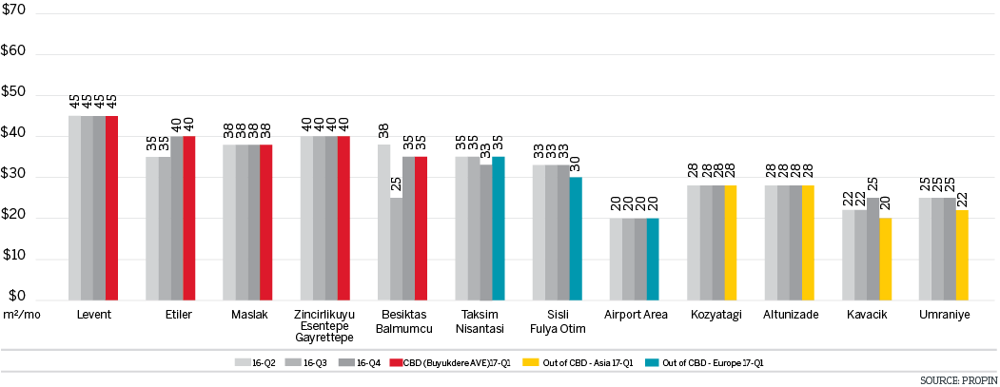

CHANGES IN AVERAGE RENTAL RATES OF CLASS A BUILDINGS The Last Four Quarters

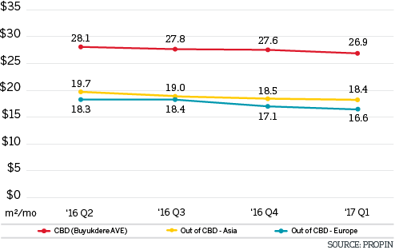

CHANGES IN AVERAGE RENT RATESOF CLASS B BUILDINGS The Last Four Quarters

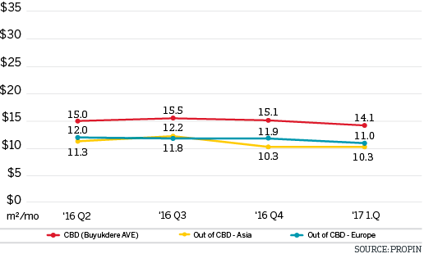

DISTRIBUTION OF CLASS A OFFICE STOCK BY DISTRICT CATEGORY 2017 The First Quarter

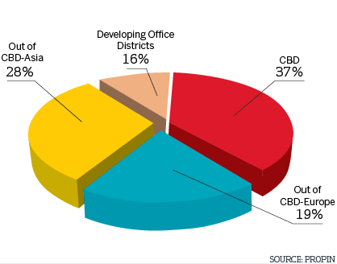

DISTRIBUTION OF CLASS A OFFICE STOCK BY DISTRICT 2017 The First Quarter

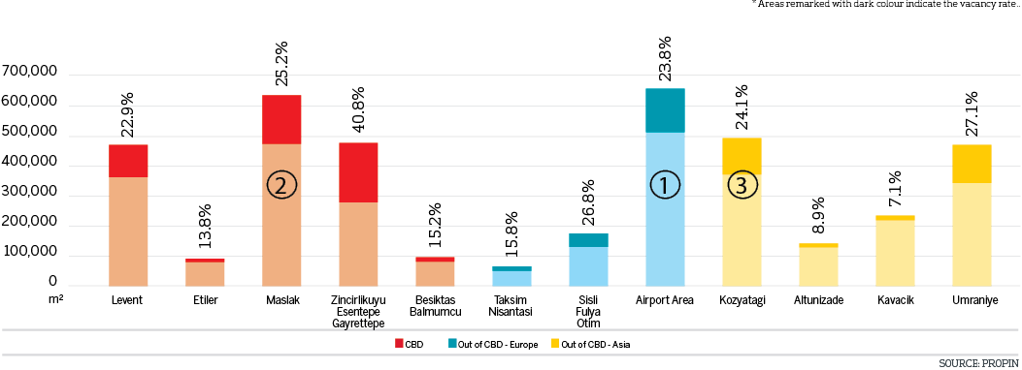

EDITOR’S NOTE: Propin Property Investment Consultancy is a commercial property investment consultancy company specializing in the “office” sector. Propin provides advisory and agency services to property users, landlords and property investors. The company’s service covers Istanbul and other metropolises where the office market is developing.
Founded in 2005, Propin has made an impact in the sector within a short period of time, exemplified by its quality of work and service. Obvious indicators of its success are the references from the most prestigious Turkish and global companies. Propin, with a quality and productivity accompanied by expertise, provides a full range of service to its customers in the office market. From its inception, its guiding principle has been to never make concessions on business ethics. It gives importance to trust that has been built up in the sector and strives to maintain that trust in the future.
www.propin.com.tr | info@propin.com.tr

