ISTANBUL
OFFICE REPORT
PRESS KIT
PRESS BULLETIN

CONTACT INFORMATION
2017
THIRD QUARTER
Propin Property Investment Consultancy
Buyukdere Caddesi, Gokfiliz İs Merkezi
No. 8/22 F. 9 Mecidiyekoy, Istanbul
T +90 212 217 85 55
F +90 212 217 85 53
info@propin.com.tr | www.propin.com.tr

PROPIN PROPERTY INVESTMENT CONSULTANCY PRESS BULLETIN
31.10.2017
2017 THIRD QUARTER ISTANBUL OFFICE MARKET GENERAL OVERVIEW
Propin, which offers Property Investment Consultancy service about renting and acquisition of offices, prepares a report on the Istanbul Office Market every three month; the report of the third quarter of 2017 has just been released. It shows the changes that occurred in the office market during July, August, and September as well as shares Propin’s predictions of Propin for the upcoming periods.

Istanbul Office Market passed a hectic period in the first quarter of 2017.
In the report, Propin stated that, The Istanbul Office Market experienced a hectic period in the third quarter of 2017. It is conveyed that stock kept increasing. Propin indicated that, in addition to the rise in stock, the demand side was also intense and some transactions were executed for office areas where advantageous financial terms were bargained for. It is stated that, despite the occurrence of some leasing transactions, the vacancy rate still rose due to this overall increase in stock.

The office stock grew rapidly.
In the report, Propin said that, Istanbul Class A office stock experienced a 457.000 m² increase, demonstrating the fastest growth in the last two years. Propin emphasized that, new buildings in Kagithane, Maslak and the Airport District constituted half, 27% and 16% respectively of the recently added stock in a single quarter. Considering the total stock size, it has been observed that the stock share of the CBD, Out of CBD-Europe, Out of CBD-Asia and Developing Office Districts (Kagithane, Bomonti-Piyalepasa, Kartal-Maltepe, West Atasehir) was measured at 36%, 20%, 25%, and 19% respectively.

Vacancy Rate increased in the CBD , decreased in Out Of CBD-Europe yet steady in Out of CBD-Asia.
In the report, one can say that, consequently, an almost 21% increase was observed in the vacancy rate of Class A office buildings in the CBD over the last four quarters. It is underlined that, class A stock increase in Maslak in the third quarter of 2017 played a role in the hike in vacancy rate for Class A office buildings in the CBD. It is said that, the vacancy rate, measured at 24.2% in the fourth quarter of 2016, declined to 21.8% in the third quarter of 2017. In the report, it is also informed that the vacancy rate for Class A office buildings in Out of CBD-Asia, which increased to 20.6% in the first quarter of 2017, remained at the same level in the following two quarters.

Average rental rates in the Istanbul Office Market decreased.
In the report prepared by Propin, it is stated that, the average rental rate for Class A office buildings in the CBD was determined to be $US 25 /m² /month in the third quarter of 2017. It is mentioned that a 10% decline over the last four quarters was witnessed in the in the Class A office buildings in the CBD. It is informed that, the average rental rate for Class A office buildings in Out of CBD-Europe showed a downward trend starting in the fourth quarter of 2016 and was recorded as $US 15.5 /m² /month in the third quarter of 2017. In the report, it is said that, the average rental rate for Class A office buildings in Out of CBD-Asia fluctuated between $US 18 - 19 /m² /month between the last quarter of 2016 and the third quarter of 2017.

The summary of the report prepared by Propin “Istanbul Office Market in the third quarter of 2017” based on the latest data, is given below;

- The vacancy rate for Class A office buildings in the Central Business District (CBD) increased to
31% and to 15.1% for Class B office buildings. The average rent for Class A office buildings in the
CBD was $US 25 /m² /month and $US 13.6 /m² /month for Class B office buildings.

- For Class A office buildings in Out of CBD-Europe, the vacancy rate was determined to be 21.8%
and average rent was $US 15.5 /m² /month.

- The vacancy rate for Class A office buildings in Out of CBD-Asia was at a level of 20.6%. The average rent for Class A office buildings was $US 18.3 /m² /month.

- The top prime rent ($US 44 /m² /month) in the third quarter of 2017 was observed in Levent,
which is located in the CBD.

Levent was the district where the prime rent was set!
In the report that Propin has prepared, it is mentioned that, Levent was the district where the highest rent was demanded in Istanbul in the third quarter of 2017. It is said that, while the highest rent demanded in Levent was $US 44 /m² /month, this figure is $US 1 lower than the figure asked in the previous three consecutive quarters. Also in the report, it is revealed that, as in the previous quarter, the top prime rent asked in Out of CBD-Europe was observed in Sisli-Fulya-Otim as $US 29 /m² /month. Propin conveyed that in Out of CBD-Asia, Kozyatagi was the district where $US 27 /m² /month was asked as the top prime rent.

2017 THIRD QUARTER ISTANBUL OFFICE MARKET - GRAPHICS

31.10.2017

VACANCY RATES BY DISTRICT CATEGORY 2017 The Third Quarter

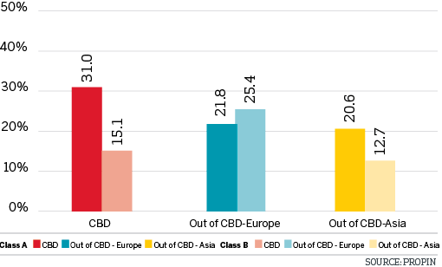

VACANCY RATES BY DISTRICT 2017 The Third Quarter

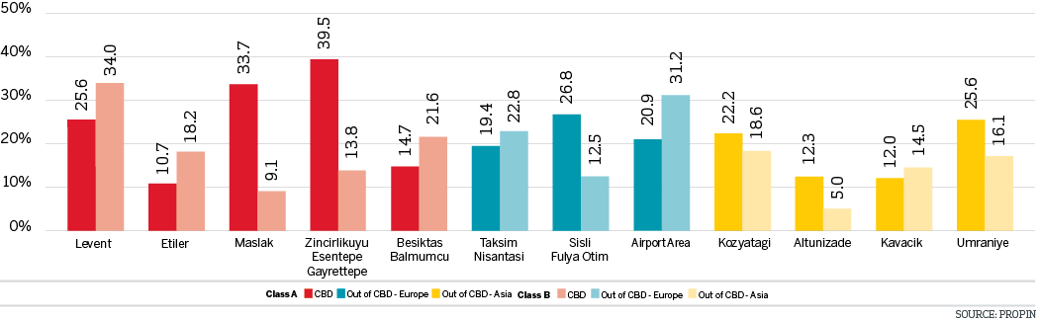

CHANGES IN VACANCY RATES OF CLASS A BUILDINGS The Last Four Quarters

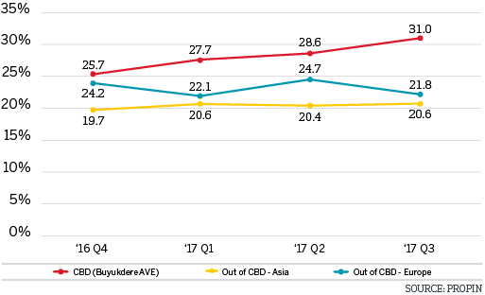

CHANGES IN VACANCY RATES OF CLASS B BUILDINGS The Last Four Quarters

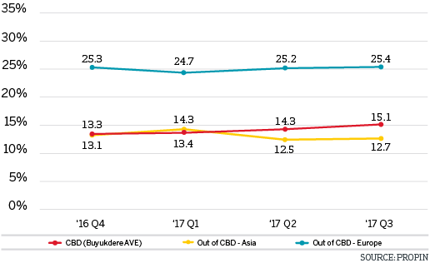

AVERAGE RENTAL RATES BY DISTRICT CATEGORY 2017 The Third Quarter

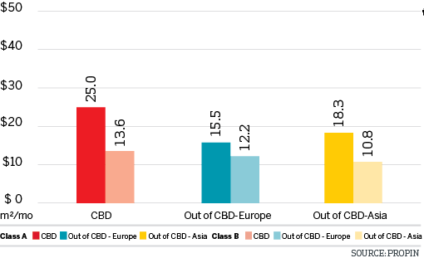

AVERAGE RENTAL RATES BY DISTRICT 2017 The Third Quarter

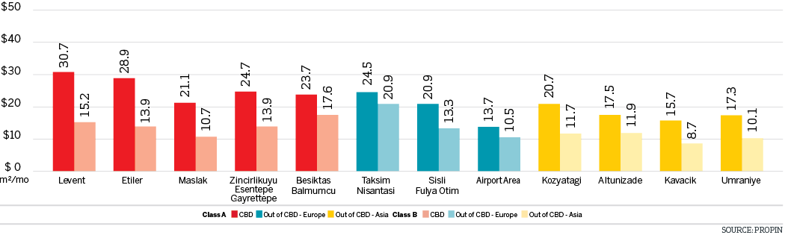

LISTING PRICES OF PRIME RENT BY DISTRICT IN ISTANBUL The Last Four Quarters

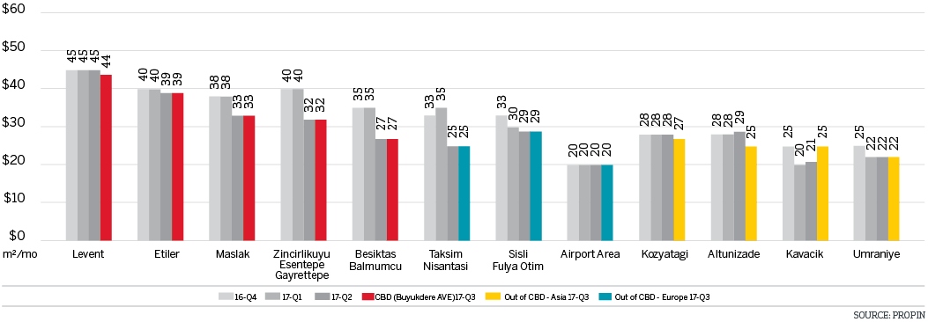

CHANGES IN AVERAGE RENTAL RATES OF CLASS A BUILDINGS The Last Four Quarters

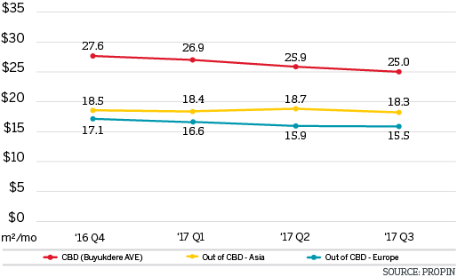

CHANGES IN AVERAGE RENT RATESOF CLASS B BUILDINGS The Last Four Quarters

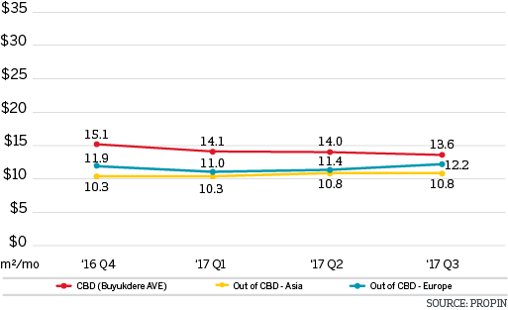

DISTRIBUTION OF CLASS A OFFICE STOCK BY DISTRICT CATEGORY 2017 The Third Quarter

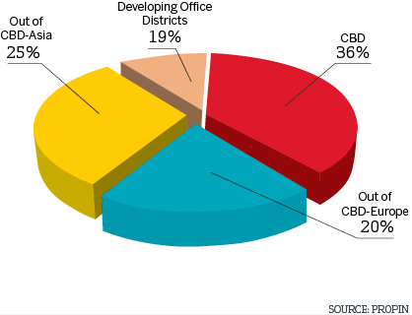

DISTRIBUTION OF CLASS A OFFICE STOCK BY DISTRICT 2017 The Third Quarter

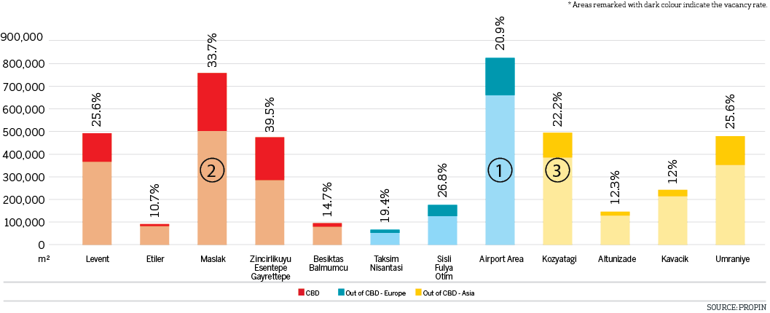

EDITOR’S NOTE: Propin Property Investment Consultancy is a commercial property investment consultancy company specializing in the “office” sector. Propin provides advisory and agency services to property users, landlords and property investors. The company’s service covers Istanbul and other metropolises where the office market is developing.
Founded in 2005, Propin has made an impact in the sector within a short period of time, exemplified by its quality of work and service. Obvious indicators of its success are the references from the most prestigious Turkish and global companies. Propin, with a quality and productivity accompanied by expertise, provides a full range of service to its customers in the office market. From its inception, its guiding principle has been to never make concessions on business ethics. It gives importance to trust that has been built up in the sector and strives to maintain that trust in the future.
www.propin.com.tr | info@propin.com.tr

